|  |  |  |
| --- | --- | --- |
| **Students Details** |  | nibm LOGO |
| **Module Name:** | Electronics and Computer Architecture |
| **Module Lecturer/ Course Coordinator:** | R.G. Vimukthi Pathirana |
| **Department:** | School of Computing |
| **Submission Due on :** | 30th March 2023 | |
| **Type of Coursework:** | Group | |
| **Title of the Coursework:** | The Smart Ground Stadium | |

|  |  |  |
| --- | --- | --- |
| ***Students Details :*** | | |
|  | **Student No.** | **Student Name** |
| 01 | CODSE22.3F-090 | M.T.A.INSHIRAFF |
| 02 | CODSE22.3F-123 | M.Y.A.A.SIMAK |
| 03 | CODSE22.3F-065 | M.T.A.RAHEEM |
| 04 | CODSE22.3F-043 | M.N.IFFATH |
| 05 |  |  |
| 06 |  |  |
| 07 |  |  |
| 08 |  |  |
| 09 |  |  |
| 10 |  |  |

|  |
| --- |
| **Office use only :** |
| ***Date Stamp Required of the Department*** |

**NATIONAL INSTITUTE OF BUSINESS MANAGEMENT**

**DIPLOMA IN SOFTWARE ENGINEERING**

**COURSEWORK ONE**

**ELECTRONICS AND COMPUTER ARCHITECTURE**

**The Smart Ground Stadium**

**SUBMITTED BY**

**M.T.A.INSHIRAFF CODSE22.3F-090**

**M.Y.A.A.SIMAK CODSE22.3F-123**

**M.T.A.RAHEEM CODSE22.3F-065**

**M.N.IFFATH CODSE22.3F-043**

**Date of Submission: 30/03/2023**

# **DECLARATION**

We hereby declare that this thesis report is based on our research and original work excluding the material duly acknowledged. The experimental work is almost entirely our own and indicated with collaborative contributions and has not been submitted earlier or concurrently in any other diploma, or degree program of NIBM or any other university.

Name with Initials Index Number Signature

**………………………………………**

**R.G. Vimukthi Pathirana**

**Supervisor**

**Consultant/ Lecturer Colombo Branch**

**National Institute of Business Management**

**Date:………………………………**

# **SUMMARY**

The Smart Ground Stadium is an innovative project that aims to improve the experience of visitors to stadiums by leveraging technology. The project includes several sub-projects, including the Pavilion Motion Sensor Light Circuit, People Counting System with a gate, and the Automatic Night Light Circuit.

The Pavilion Motion Sensor Light Circuit is designed to provide lighting in pavilions and seating areas in the stadium. The system uses motion sensors to detect the presence of people and turns on the lights in the pavilion or seating area. The system helps to conserve energy by only turning on the lights when people are present and turning them off when the area is empty.

The People Counting System with a Gate is a system designed to manage the flow of people in and out of the stadium. The system uses sensors to count the number of people entering and exiting the stadium and automatically closes a gate once the maximum limit of seven people is reached. This helps to prevent overcrowding in the stadium and ensures that the maximum capacity of the stadium is not exceeded.

The Automatic Night Light Circuit is a system designed to provide lighting in the stadium during night events. The system uses sensors to detect changes in light levels and automatically turns on the lights when it gets dark. The system helps to improve safety in the stadium by providing sufficient lighting for visitors during night events.

The Smart Ground Stadium is an important initiative that has the potential to improve the experience of visitors to stadiums by providing innovative solutions to common problems. The sub-projects included in the project, such as the Pavilion Motion Sensor Light Circuit, People Counting System with a gate, and the Automatic Night Light Circuit, demonstrate the project's commitment to providing a safe and enjoyable experience for visitors to the stadium.

## **TABLE OF CONTENT**

**DECLARATION** 4

**SUMMARY** 5

TABLE OF CONTENT 6

**CHAPTER 01** 7

1.1 Introduction 7

1.2 Features of the Product 8

**CHAPTER 02** 9

2.1 Circuit Components 9

2.2 Truth Tables 10

2.3 K Maps 11

2.4 Circuit Diagrams 12

**CHAPTER 03** 13

3.1 Results of the operation 13

**CHAPTER 04** 14

4.1 Limitations, Recommendations and Conclusion 14

**REFERENCES** 15

**APPENDIX** 16

# **CHAPTER 01**

## Introduction

The Smart Ground Stadium Pavilion project is an innovative solution designed to enhance the user experience and ensure the safety and security of visitors to outdoor stadiums and pavilions. This project incorporates several features, including a motion sensor light circuit, a people counting system, and an automatic night light circuit, to provide a comprehensive solution that meets the unique needs of outdoor venues.

The motion sensor light circuit is designed to automatically turn on the lights when someone enters the pavilion and turn them off when they leave. This feature helps to conserve energy and ensure that visitors can easily navigate the space, even in low-light conditions.

The people counting system is another important component of this project. This system uses advanced sensors to count the number of people entering and exiting the pavilion. When the maximum limit of 7 people is reached, the gate is automatically closed to prevent overcrowding and ensure the safety of visitors.

Finally, the automatic night light circuit ensures that the pavilion remains illuminated throughout the night, providing a safe and secure environment for visitors. This circuit is designed to automatically turn on the lights at dusk and turn them off at dawn, eliminating the need for manual intervention.

In summary, the Smart Ground Stadium Pavilion project is an innovative solution that incorporates advanced technologies to enhance the user experience, ensure the safety and security of visitors, and conserve energy. By combining a motion sensor light circuit, a people counting system, and an automatic night light circuit, this project provides a comprehensive solution that meets the unique needs of outdoor venues.

## Features of the Product

## 

1.2.1. Pavilion motion sensor light circuit

•Automatic on/off function triggered by motion detection

•Energy-efficient as it saves electricity by turning off the light when not in use

•Simple and cost-effective circuit design

•Can be easily assembled on a breadboard

•Uses common components such as CD4017 IC, IR module, and a breadboard

•Suitable for DIY home automation projects.

1.2.2. Pavilion Gate with Counter

•People counting to a maximum of 7.

•Automatic gate closure when maximum limit is reached.

•Use of Arduino UNO for control and processing.

•IR proximity sensor for detecting people.

•Servo motor for gate closure mechanism.

•16x2 LCD i2c display for displaying real-time count and status updates.

•Easy connectivity with jumper wires.

1.2.3. Stadium night light

•The circuit design has been simplified and made more affordable so that both enthusiasts and hobbyists can use it.

•Makes use of the photoresistor's capacity to recognize variations in lighting conditions.

•Can be utilized in a range of applications, such as automatic illumination, backyard lighting, and more.

•The output of the circuit is connected to an LED, which comes on in response to changes in lighting conditions.

# **CHAPTER 02**

## 2.1 Circuit Components

2.1.1. Components of Pavilion motion sensor light circuit

* CD4017 IC - 1
* BC547 Transistor - 1
* 100uF Capacitor - 1
* 220-ohm 0.25watt Resistors - 2
* LED 5mm - 1
* 1N4007 Diode - 1
* 5 v SPDT (250VAC) Relay - 1
* Bread Board - 1
* Connecting wire
* 9v battery or Mobile charger
* IR module

2.1.2. Components of Pavilion Gate with Counter

* Arduino UNO-1
* IR Proximity Sensor-2
* Servo Motor-1
* 16x2 LCD i2c Display-1
* Jumpers

2.1.3. Components of Automatic Night Light Circuit

* Breadboard
* IC CD 4011
* LDR
* LED
* Resistor 100Ω
* Resistor 1kΩ
* Connection wires
* Jumper cable

## 2.2 Truth Tables

Truth table for automatic night light

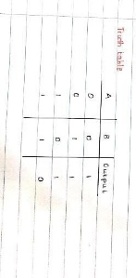

2.3 K Maps

K Map of Automatic Night Light Circuit

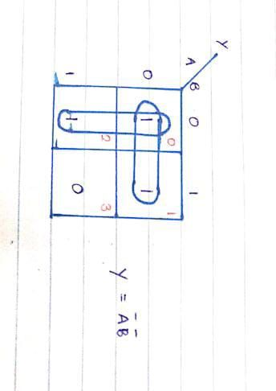

## 2.4 Circuit Diagrams

2.4.1. Circuit diagram of Automatic Night Light Circuit

## 

2.4.2. Circuit diagram of Pavilion motion sensor light circuit

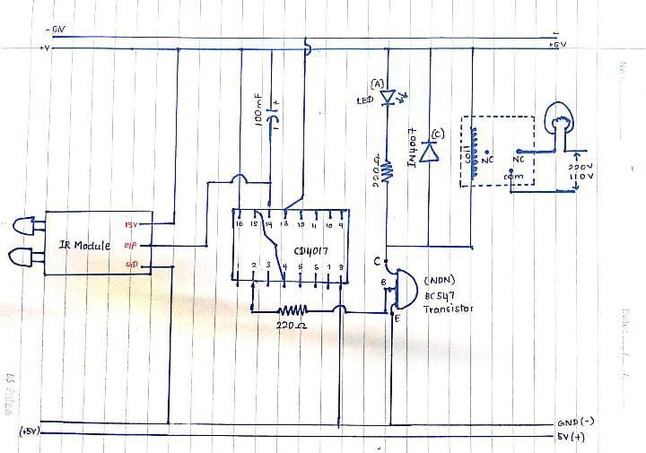

2.4.3. Circuit diagram ofPavilion Gate with Counter

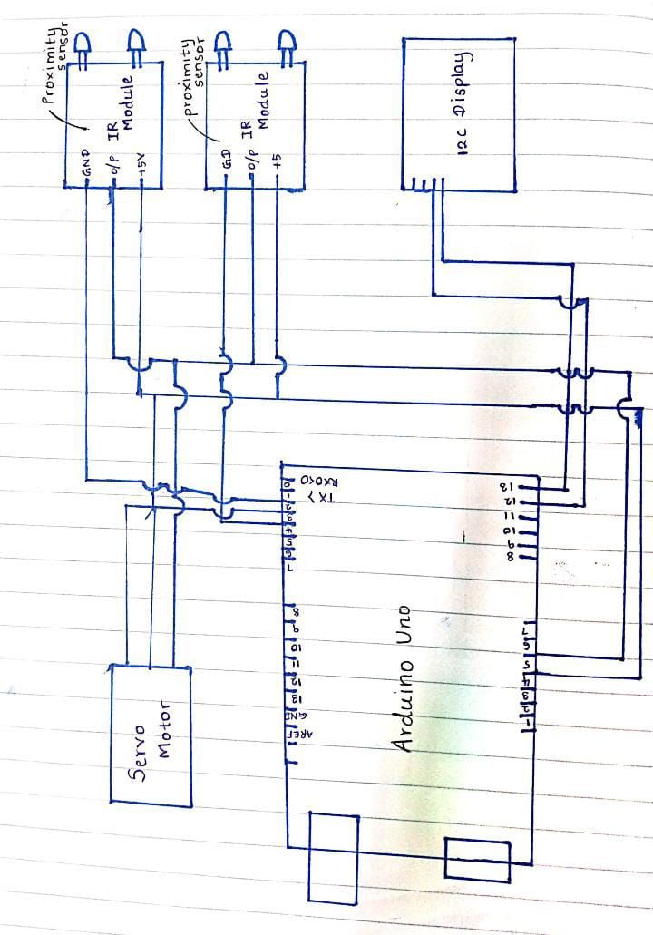

# **CHAPTER 03**

## 3.1 Results of the operation

* "Automatic Night Light Circuit" project aims to turn on the night light automatically in the absence of sufficient light. The result of the operation would be a more convenient and energy-efficient way of lighting up a ground during nighttime.
* Results of the operation of “Pavilion motion sensor light circuit” is automating the process of turning on and off the lights in a pavilion through detecting the motion. The result of the operation would be a more convenient and hands-free way of controlling the lights.
* “Pavilion Gate with Counter” detects the motion of the people and opens the gate automatically and closes when a person enters. When maximum limit of 7 people enters the gate, gate will not open even though it detects the motion of the people to prevent overcrowding in the pavilion.

# **CHAPTER 04**

## 4.1 Limitations, Recommendations and Conclusion

4.1.1. Pavilion motion sensor light circuit

Limitations:

•Only works in dark environments where the IR module can detect motion.

•May not work properly if the sensor is obstructed by objects or if there are interference sources.

•Requires a breadboard and some technical knowledge to assemble.

•The circuit is designed for low power devices such as LED bulbs and may not be suitable for high power appliances.

Recommendations:

•Use high-quality components to ensure proper and safe operation of the circuit.

•Follow proper safety precautions when working with high voltage circuits.

•Ensure that the circuit is properly grounded to prevent electric shock.

•Consider adding a manual override switch for situations when the motion sensor is not desired.

•Consider using energy-efficient LED bulbs for longer lifespan and energy savings.

4.1.2. Pavilion Gate with Counter

Limitations:

•Limited to counting to a maximum of 7 people only.

•Requires a clear line of sight between the IR proximity sensor and people passing through.

•May not be accurate if people are moving too quickly or in a group.

•Cannot distinguish between people and other objects.

•Servo motor may not be strong enough to close a heavy gate.

Recommendations:

•Ensure proper calibration of the IR proximity sensor to accurately detect people.

•Use high-quality components for better reliability and durability.

•Implement safety measures to prevent accidents or injury, such as an emergency stop button.

•Test the circuit thoroughly before implementing it in a real-life scenario.

4.1.3. Automatic Night Light Circuit

Limitations:

•If the photoresistor or other components are broken or improperly installed, the circuit may not function properly.

•Extreme illumination or exposure of the photoresistor to direct sunlight may prevent the circuit from functioning.

•The circuit's functionality can be impacted if it is sensitive to other light sources, including streetlights or automobile headlights.

Recommendations:

•Use high-quality parts to guarantee dependable circuit operation.

•Check the circuit to make sure it is operating properly before usage.

•Place the photoresistor where it will be most effective at detecting changes in light.

• When working with electrical components, take the proper safety procedures.

Conclusion

In conclusion, purpose of our smart stadium project is significant advancement in the sports industry, offering a range of benefits for both fans and stakeholders. Automatic night ground light helps to on automatically when it is dark. Our smart gate counter utilizes a range of sensors and other electronic components, along with the Arduino microcontroller, to accurately track the number of people entering and exiting a given space. The system is capable of providing real-time data on occupancy levels, as well as alerts when the maximum capacity is reached. Our team designed and implemented a system that uses motion sensors to detect movement in the pavilion area, and automatically turns on the lights to provide adequate illumination. This innovative technology eliminates the need for manual intervention, while providing a reliable and energy-efficient solution.

## **REFERENCES**

1.Electronics For You (https://electronicsforu.com/): This website provides information and resources on electronics projects, circuits, and tutorials, including motion sensor circuits, people counting systems, and automatic night light circuits.

2.Instructables (https://www.instructables.com/): Instructables is a website that features user-generated DIY projects and step-by-step instructions on various topics, including electronics.

3.Circuit Digest (https://circuitdigest.com/): This website has a section dedicated to microcontroller-based projects and provides tutorials and articles on various circuits, including motion sensor circuits and people counting systems.

4.All About Circuits (https://www.allaboutcircuits.com/): This website has a vast collection of articles, tutorials, and projects on electronics and circuits, including various sensors and automation-related topics.

5.Hackster.io (https://www.hackster.io/): This website provides a community for electronics and hardware projects and provides tutorials and articles on various projects, including motion sensor circuits and people counting systems.

# **APPENDIX**

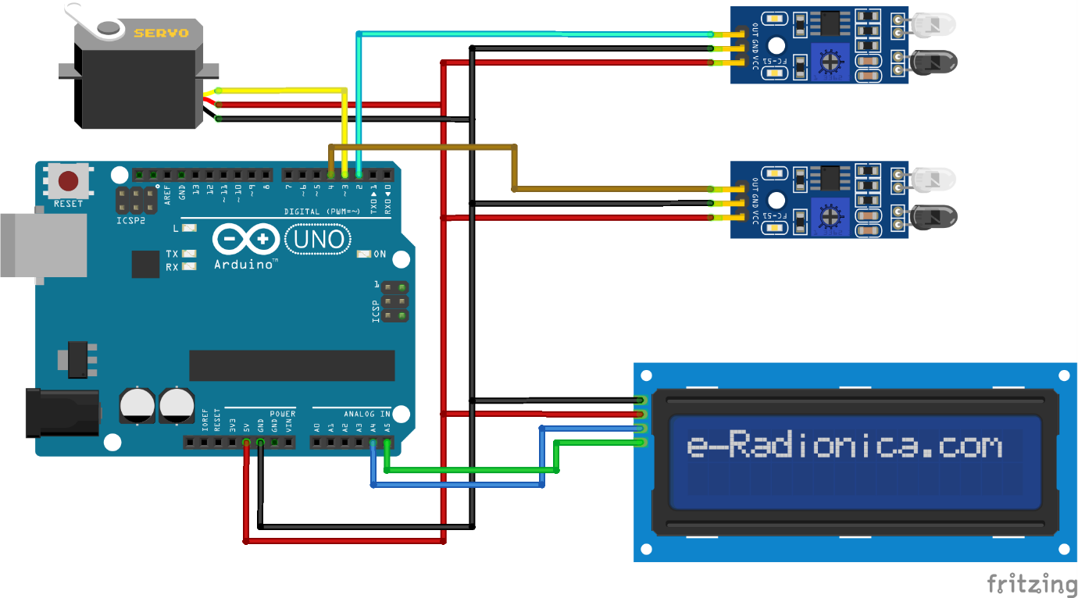



***Figure 1 counter system***

***Figure 2 Automatic Night Light Circuit***

